Guidance Notes on the Use of Security Labels for Samples of
Concrete Cube/Concrete Core/Steel Bar/Bituminous Materials/Fill Materials/
Fall Protection-Safety Nets/Steelwork Materials and Associated Mechanical Fasteners

Background

In recent years, the ICAC has conducted assessments on the construction materials compliance testing services provided by the Public Works Laboratories (PWL). One of the recommendations made by the ICAC was that the PWL should enhance the security of the sample delivery process from project sites to testing laboratories. In response, the PWL have introduced the use of security labels for seven types of frequently-tested samples, namely concrete cube, concrete core, steel bar, bituminous materials, fill materials, fall protection-safety nets, steelwork materials and associated mechanical fasteners.

To enhance the reliability of the compliance testing services, public works projects should apply security labels to samples of concrete cube, concrete core, steel bar, bituminous materials, fill materials, fall protection-safety nets, steelwork materials and associated mechanical fasteners prepared under their contracts. Instructions on how to place security labels on samples of concrete cube, concrete core, steel bar, bituminous materials, fill materials, fall protection-safety nets, steelwork materials and associated mechanical fasteners are presented on pages 4 to 16 of the Guidance Notes.

Guidelines

- Project site staff shall fill in a “Collection/Return of Security Labels” form on page 3 of the Guidance Notes. Authorized persons appointed by project officer in-charge could collect the security labels along with the above duly completed Original Form from the following address:
Lab 3 Section,
Rm 215, 2/F, PWCL Building,
2B Cheung Yip Street,
Kowloon Bay, Kowloon
(Office hours: 8:30-12:00 & 13:15-17:00)

- The person assigned to collect the security labels shall either pre-registered with the PWL upon completion of Form No. C Eng D (GEO) 2007e, “Registration Form for Testing of Construction Materials”, or bear with the authorization letter issued by the Works Project Officer in-charge or his delegate. A person, who fails to show a valid identity, will not be allowed to collect the security labels.

- When making requests for concrete cube and steel bar testing services, project site staff shall record the security label numbers on the respective test request forms.

- Security labels assigned to each public works contract are only for the exclusive use of that contract. After completion of the contract, project site staff must return the remaining labels to the Lab 3 Section of PWCL for cancellation. In no circumstances shall project site staff use them in other contracts or transfer them to other parties.

- It should be noted that the use of security labels is not a substitute for the requirement of supervision by ER’s staff on sampling, transport or delivery of samples to the PWL according to the Project Administration Handbook for Civil Engineering Works, 2020 Edition, Section 5.15 of Chapter 7.

- For enquiries, please contact STO/Lab3 of the PWCL at 2305 1115 / 2305 1547.
混凝土磚/混凝土芯/鋼筋/瀝青/填料/墜落防護安全網/鋼結構物料及相關緊固件樣本
保安條碼的應用指引

背景

過往幾年廉政公署曾對工務試驗所的物料試驗作出評估，其中一項建議是要求工務試驗所加強對試驗樣本由工地運送到試驗所的保安。因應廉政公署的建議，工務試驗所引入了保安條碼系統在七類頻密常規試驗樣本上使用，即混凝土磚、混凝土芯、鋼筋、瀝青、填料、墜落防護安全網、鋼結構物料及相關緊固件樣本。

工務工程項目應在混凝土磚、混凝土芯、鋼筋、瀝青、填料、墜落防護安全網、鋼結構物料及相關緊固件樣本上採用保安條碼，以確保試驗服務的可靠性。保安條碼的使用方法請參閱本應用指引第四至第十六頁。

相關指引

- 項目工地人員須填妥本指引第3頁的「保安條碼之領取/退還」表格。已授權員工可帶同上述已填妥表格(正本)到下列地址領取保安條碼：
九龍灣祥業街2B
工務中央試驗所大樓二樓215室
試驗組別3
（辦公時間：8:30-12:00 及 13:15-17:00）

- 被指派收集保安條碼的人員需預先登記在“建築材料測試登記表”(表格號碼 : C Eng D (GEO) 2007e) ，或攜帶由工程項目負責人或其代表所簽發的授權書。任何人仕若無法出示有效的身份証明，將不會獲分發保安條碼。

- 在要求混凝土磚及鋼筋試驗服務時，項目工地人員須將保安條碼編號填在相關申請試驗表格上。

- 每一項工務工程項目會被編配一組特定保安條碼，在有關工程項目竣工後，剩餘的保安條碼必須退還工務中央試驗所試驗組別3。項目工地人員在任何情况下均不可將剩餘的保安條碼轉交予其它工程項目或人士使用。

- 保安條碼的應用並非取代土木工程管理手冊2020版，第7章，第5.15段要求工程代表之監工必須巡查抽取樣本及運送到工務試驗所的過程。

- 若有任何查詢，歡迎致電工務中央試驗所高級技術主任/試驗3 (電話號碼: 2305 1115 / 2305 1547)。

Collection/Return* of Security Labels
Department
Contract No.
Job No.
Job Title
Works Site Location

 | Type (Select appropriate box) | Quantity
 | Security label for concrete cube
 | Security label for concrete core
 | Security label for steel bar
 | Security label for bituminous materials
 | Security label for fill materials
 | Security label for steel strip samples for tensile test
 | Security label for steel dice samples for impact test (and mechanical fasteners)
 | Security label for fall protection-safety nets samples for burning behaviour test

Requested by: |  |  | (To be signed by inspectorate staff or above)
Signed
Name
Post
Date
Important Note
Security labels assigned to each public works contract are only for the exclusive use of that contract. After completion of the contract, project site staff must return the remaining labels to Lab3 Section of PWCL for cancellation. In no circumstances shall project site staff use them in other contracts or transfer them to other parties.
For PWL use only
 | Type |  |  |  |  | Quantity |  |  | Security label number
 | Security label for concrete cube |  |  |  |  |  |  |  | CA
 | Security label for concrete core |  |  |  |  |  |  |  | CC
 | Security label for steel bar |  |  |  |  |  |  |  | SA
 | Security label for bituminous materials |  |  |  |  |  |  |  | BA
 | Security label for fill materials |  |  |  |  |  |  |  | FM
 | Security label for steel strip samples |  |  |  |  |  |  |  | ST
 | Security label for steel dice samples |  |  |  |  |  |  |  | SS
 | Security label for fall protection-safety nets |  |  |  |  |  |  |  | FT
Issued/Received* by: |  |  |  | (To be completed by PWL staff)
Signed
Name
Post
Date

For the person who collect/return the security labels
I acknowledge the receipt/return* of the above Security Labels.
Signed
Name
Post
Date
* Delete as appropriate

Instructions on placing of security label on test sample

Concrete cube

- Please complete and submit test request form C Eng D (GEO) 2309 through the LIMS e-Portal.

- Site staff should maintain a traceable numbering record for concrete cubes of their works projects.

- The “Customer Test Request Ref. No.” assigned by site staff must be unique and between 2 and 12-digit alphanumeric in length.

- Marking of concrete cube,
10 mm
10 mm
a
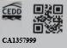
CA1357999
b

c
HY/2012/99
d
000123456789
e
A

f
28 days
g
12-09-2012

Marks a : Security label
b : Security label number
c : Contract number#
d : Customer Test Request Ref. No.#
e : Cube identification mark (A, B, C, D, E, F)#
(Please tick the appropriate box on the Form 2309 to indicate that the samples are in pairs)
f : Age (days) at which cube is requested to be tested
g : Date cube is cast

# the mark is optional for test request submitted via LIMS e-Portal

Folding process for security label for concrete cube

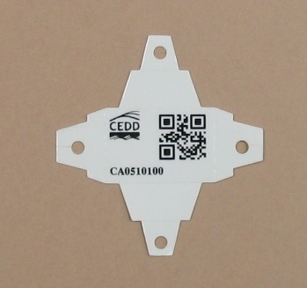 |  | 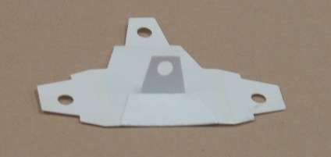
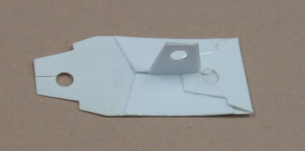 |  | 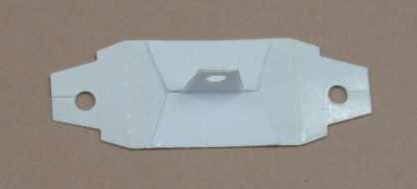
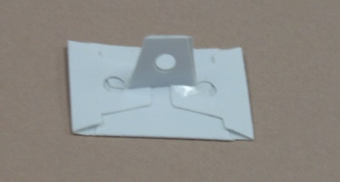 |  | 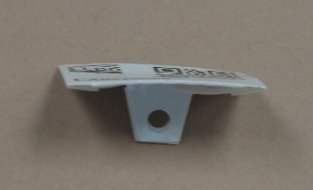
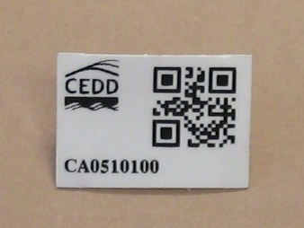

Placing security label on the surface of fresh concrete cube
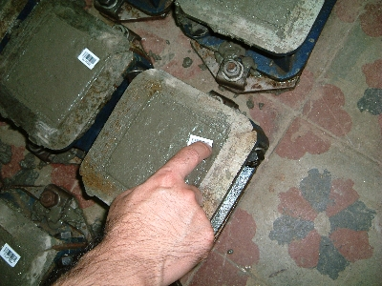

Marking of concrete cubes
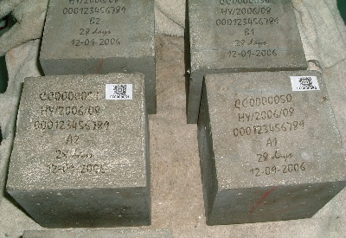

Concrete core

- Please complete and submit test request form C Eng D (GEO) 2313 through the LIMS e-Portal.

- Site staff should maintain a traceable numbering record for concrete cores of their works projects.

- The “Customer Test Request Ref. No.” assigned by site staff must be unique and between 2 and 12-digit alphanumeric in length.

- Marking of concrete core,
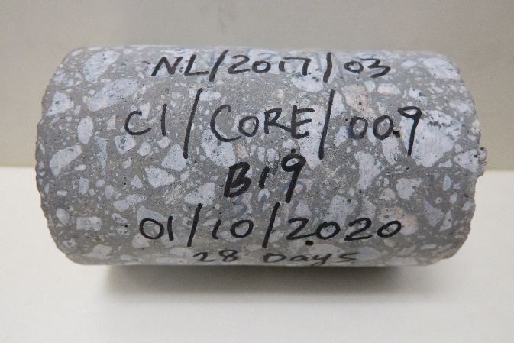
e
d
c
b
a

Marks a : Contract number
b : Customer Test Request Ref. No.
c : Core identification mark
d : Date of concrete is mixed
e : Age (days) at which core is requested to be tested

- Seal the storage bag for concrete core with security label in one of the following ways:-
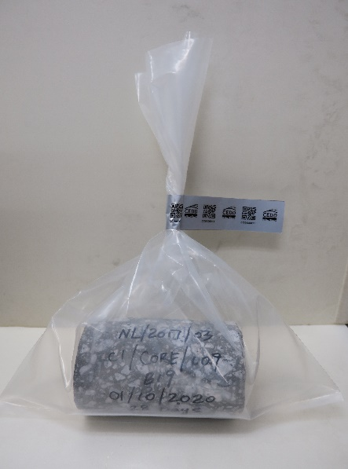
Security label

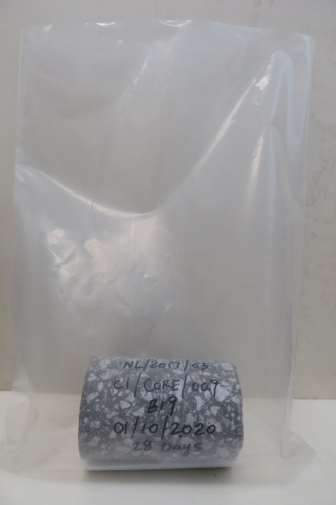 |  | 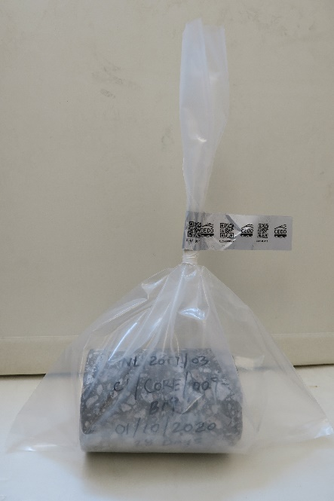  Security label  PVC adhesive tape  (Optional and not provided by PWL)
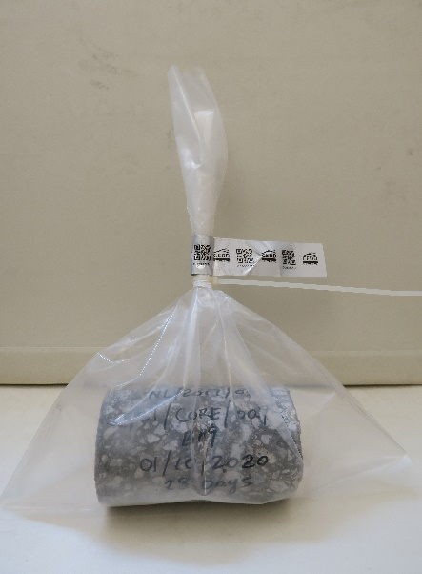
Security label
Plastic tie
(Optional and not provided by PWL)

Steel bar

- Please complete and submit test request form C Eng D (GEO) 2403 through the LIMS e-Portal.

- Site staff should maintain a traceable numbering record for steel bar of their works projects.

3. The “Customer Test Request Ref. No.” assigned by site staff must be unique and between 2 and 12-digit alphanumeric in length.

4. Marking of steel bar,

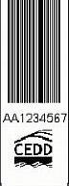
-
e
a
b
Y
Y
Y
X
X
T
X
c
d
01
S1

50 mm
330 mm
( Bar pattern should be included )

Sample length : | 1.2 m for all sizes of diameter
The Security Label (f) shall be wrapped around tightly at 50 mm to 330 mm from either end of a re-bar.

Marks : | - : Contract number#  - : Set number#  - : Specimen No.#  - : Type of test (e.g. T for tensile test  B for bend test  R for rebend test  SG for surface geometry test  CC for chemical composition)  - : Security label number  - : Security label
# the mark is optional for test request submitted via LIMS e-Portal

Bituminous bulk and core samples

- Please complete and submit test request form C Eng D (GEO) 2112 through the LIMS e-Portal.

- Site staff should maintain a traceable numbering record for bituminous samples of their works projects.

- Marking of sample storage bag
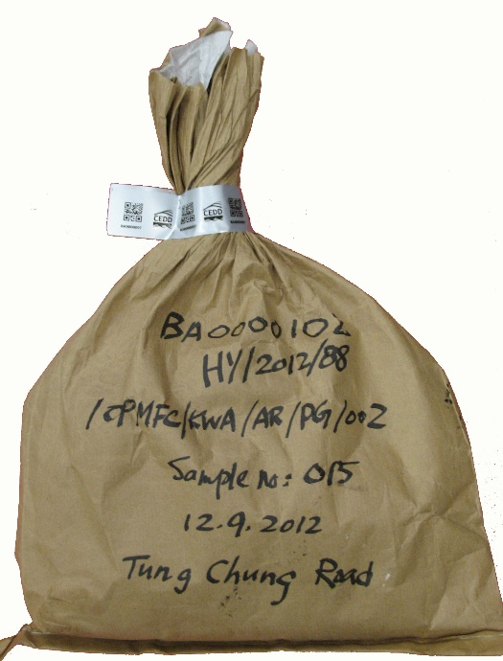
d
e
f
a
b
c
The storage bag near the opening shall be twisted and/or squeezed to form a neck for sealing with the Security Label (g).

Marks a : Security label number
b : Contract number#
c : Type of bituminous material/HyD mix ref.
d : Sample number#
e : Sampling date
f : Laying location#
g : Security label

# the mark is optional for test request submitted via LIMS e-Portal

4. Seal the storage bag for containing the bituminous bulk sample or bituminous cores with security label in one of the following ways:-
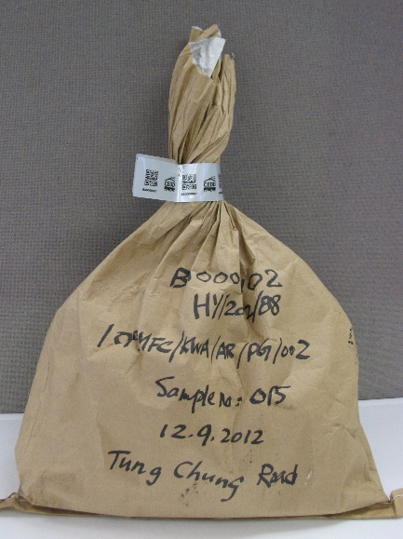
Security label
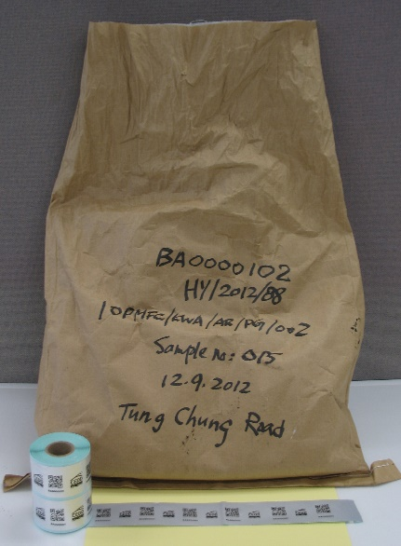 |  | 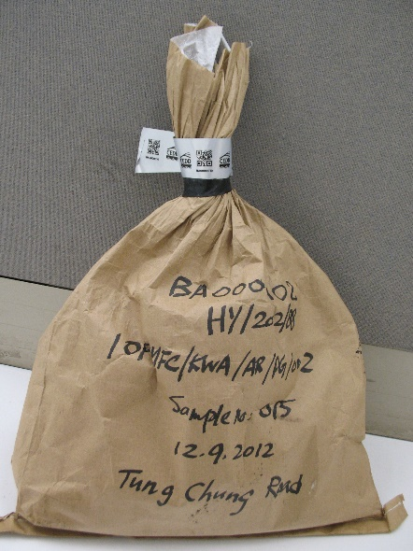  Security label  PVC adhesive tape  (Optional and not provided by PWL)
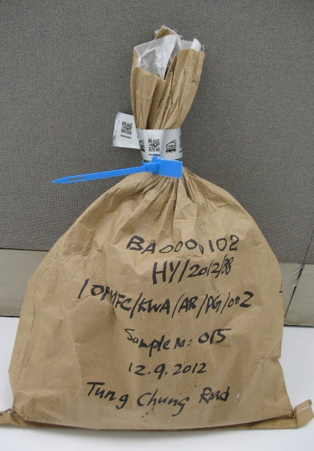
Security label
Plastic tie
(Optional and not provided by PWL)

Fill material

- Please complete and submit test request form C Eng D (GEO) 2510 through the LIMS e-Portal.

- Site staff should maintain a traceable numbering record for fill material of their works projects.

- Marking of sample storage bag
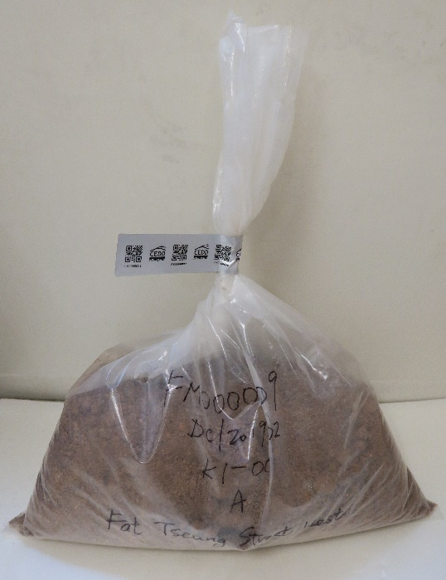
The storage bag near the opening shall be twisted and/or squeezed to form a neck for sealing with the Security Label (f).
a
b
c
d
e

Marks a : Security label number
b : Contract number#
c : Customer Test Request Ref. no.#
d : Sample number#
e : Sampling location#
f : Security label

# the mark is optional for test request submitted via LIMS e-Portal

4. Seal the storage bag for fill material with security label in one of the following ways:-
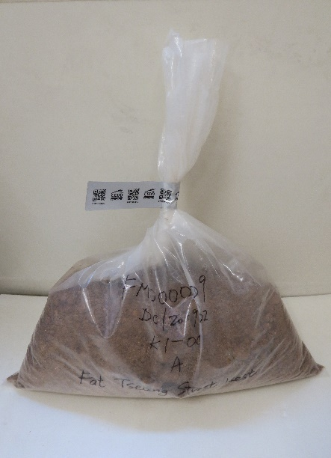
Security label
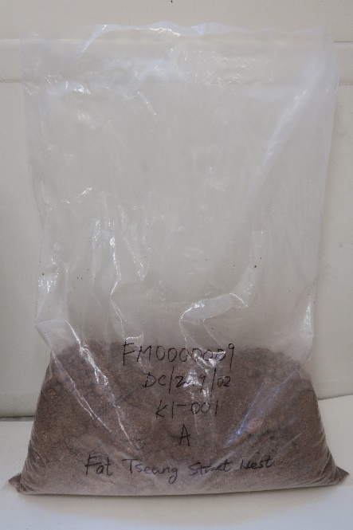 |  | 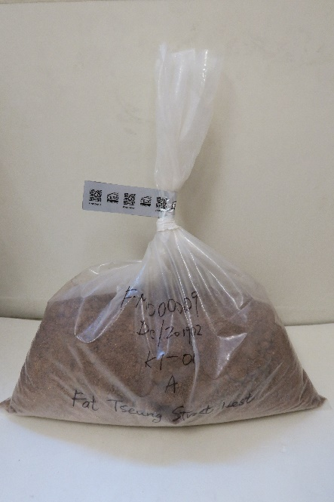  Security label  PVC adhesive tape  (Optional and not provided by PWL)
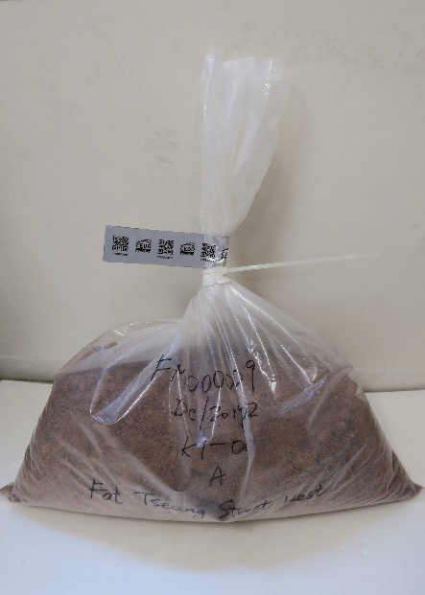
Security label
Plastic tie
(Optional and not provided by PWL)

Steel strip sample for tensile test

- Please complete and submit test request form C Eng D (GEO) 2420 through the LIMS e-Portal.

- Site staff should maintain a traceable numbering record for steelwork materials and associated mechanical fasteners of their works projects.

3. The “Customer Test Request Ref. No.” assigned by site staff must be unique and between 2 and 12-digit alphanumeric in length.

4. Marking of steel strip samples for tensile test:

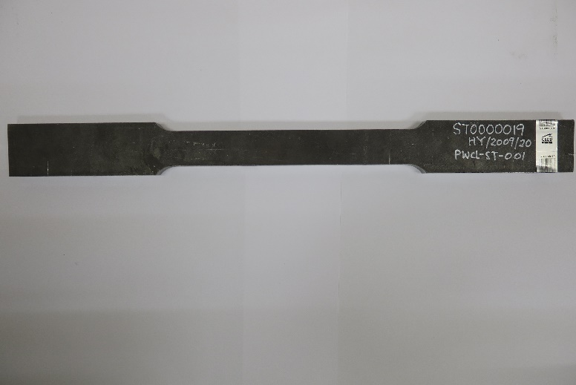
Marks a : Security label
b : Contract number#
c : Sample number#
d : Security label number

# the mark is optional for test request
submitted via LIMS e-Portal

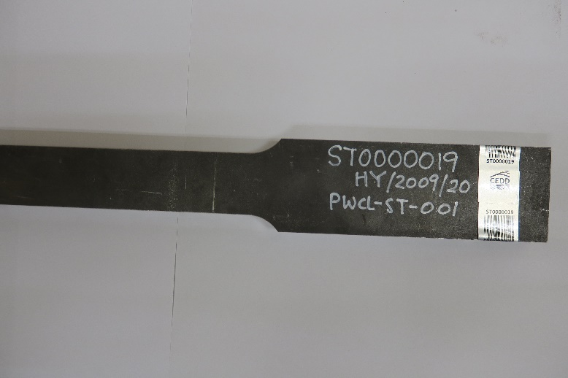
d
b
c

>15 mm
The Security Label (a) shall be wrapped around tightly at either end of a steel strip sample for tensile test.

Steel dice sample for impact test (and mechanical fasteners)

- Please complete and submit test request form C Eng D (GEO) 2420 through the LIMS e-Portal.

- Site staff should maintain a traceable numbering record for steelwork materials and associated mechanical fasteners of their works projects.

- Marking of sample storage bag:

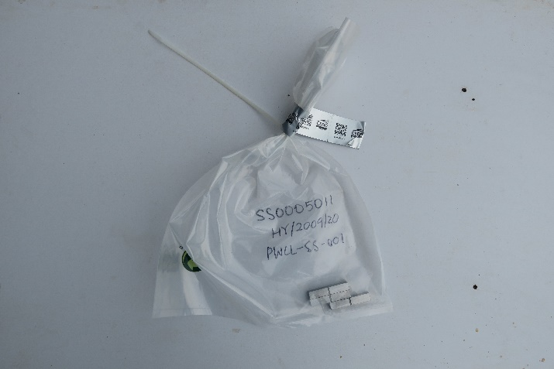
The storage bag near the opening shall be twisted and/or squeezed to form a neck for sealing with the Security Label (a).

d
b
c

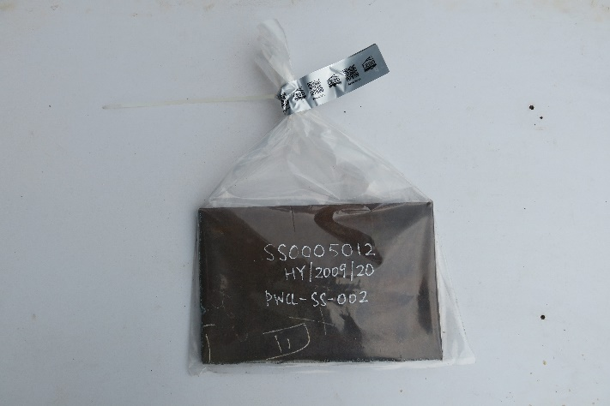

d
b
c

The storage bag near the opening shall be twisted and/or squeezed to form a neck for sealing with the Security Label (a).

Marks a : Security label
b : Contract number#
c : Sample number#
d : Security label number

# the mark is optional for test request submitted via LIMS e-Portal

Fall Protection-Safety Nets Samples for burning behaviour test

1. Please complete and submit test request form C Eng D (GEO) 2431 through the LIMS e-Portal.

2. Site staff should maintain a traceable numbering record for fall protection-safety nets sample of their works projects.

3. Marking of sample storage bag:

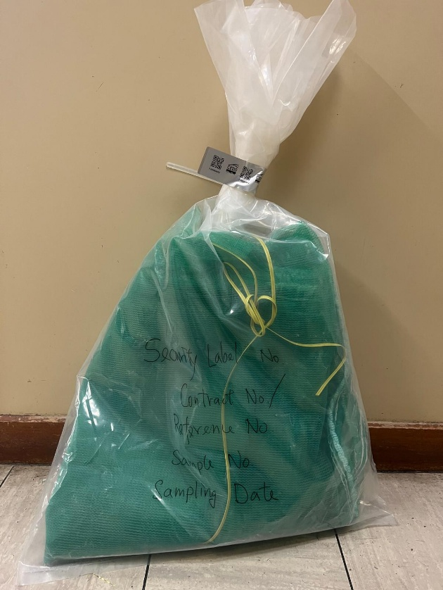
d
b
c
aa
The storage bag near the opening shall be twisted and/or squeezed to form a neck for sealing with the Security Label (e).

Marks a : Security label number
b : Contract number/Reference No.#
c : Sample number#
d : Sampling date#
e : Security label

# the mark is optional for test request submitted via LIMS e-Portal

